37.19: Let the unprimed frame be Tatooine and let the primed frame be the pursuit ship. We want the velocity 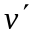 of the cruiser knowing the velocity of the primed frame and the velocity of the cruiser in the unprimed frame (Tatooine).
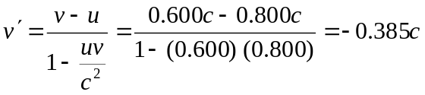
the cruiser is moving toward the pursuit ship at 